Charles Darwin University
Sydney Campus
Haymarket, NSW-2000, Australia



ASSESSMENT 4: PRT564 DATA ANALYTICS AND VISUALISATION

Submitted by: Group G6 (Sydney)
Mehruz Saif S383768
Debraj Rakshit S382665
Abrar Yasir S379181
Syed Rubayat Hossain S383306


Abstract
Executive Summary:
This study uses modern data analytics techniques to analyze avian disease outbreaks to improve early identification and response. The study aims to understand the relationship between environmental factors, such as temperature and poultry density, and disease outbreaks in birds in order to develop a simple and practical prediction tool.
We examined information obtained from the UK Animal & Plant Health Agency, along with data on livestock and climate, to identify patterns associated with cases of avian disease. One prediction model was developed to predict whether an epidemic will occur, while the other model aims to estimate the number of cases.
The results showed that when it came to making public health decisions, the second model logistic regression model—was more useful. With an accuracy rate of 77% in detecting outbreak episodes, this model could serve as a basis for the creation of automated alert systems. Even though the accuracy was only slightly better than random in many statistical tests, it still showed promise for improvement with more data.
The ability of the model to distinguish between epidemic and non-outbreak scenarios was assessed using visual aids like ROC curves, and statistical testing confirmed that the two models differed significantly.
Based on these findings, we recommend that public health agencies consider using simple prediction models, like logistic regression, to support real-time avian disease monitoring. Ultimately, by guiding more efficient resource allocation and preventing widespread epidemics, these tools may protect the health of both humans and animals.
The results of the study show how data-driven strategies can help make more informed and proactive decisions in the fields of veterinary surveillance and public health.

Flowchart of Pipeline:

- Dataset Creation and Preprocessing for Avian Disease Classification:
This section describes how we created and prepared a structured dataset for the classification of avian disease outbreaks in the UK. The aim was to collect outbreak records, add environmental data, clean and format everything carefully, and make it suitable for classification tasks. Our dataset supports later parts of the project, including regression and exploratory data analysis. The entire process was done manually in Excel to ensure data quality, and the dataset was made heterogeneous and balanced across years and variables. This foundational step was essential for the success of the project.
1.1 Primary Data Source: UK Avian Dashboard:
Our main source was the Avian Dashboard developed by the UK Animal and Plant Health Agency (APHA), published through Tableau Public (APHA, 2024). This dashboard provides detailed information on outbreaks by year, including region, bird type, diagnosis, and clinical signs.
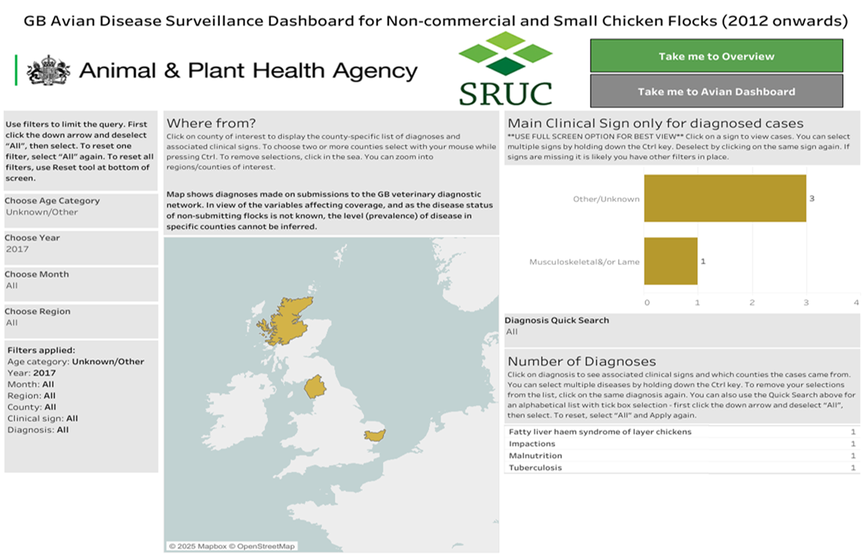
Image: Tableau Dashboard interface
Due to Tableau’s limitations, we could not automate the data download. Instead, each year from 2012 to 2024 was manually selected and exported using the “Download as Crosstab” option. Files were saved as CSV and imported into Excel for merging and further processing.
The following core fields were collected:
- Year and Month
- Country, Region, County
- Age Category
- Clinical Signs
- Diagnosis
- Number of Cases
These fields formed the base of our dataset and offered insight into the temporal and geographical distribution of outbreaks.
1.2 Adding External Environmental Data:
To meet the project requirement of working with a heterogeneous dataset, and to improve classification accuracy, we added two external variables: temperature and poultry density. These variables were selected because environmental conditions directly affect disease transmission in poultry populations.
1.3 Monthly Temperature Data:
We used the UK Met Office for historical monthly average temperature data (Met Office, 2024). We additionally used Statista, which provides detailed year-specific monthly temperatures from 2015 to 2024 (Statista, 2024).

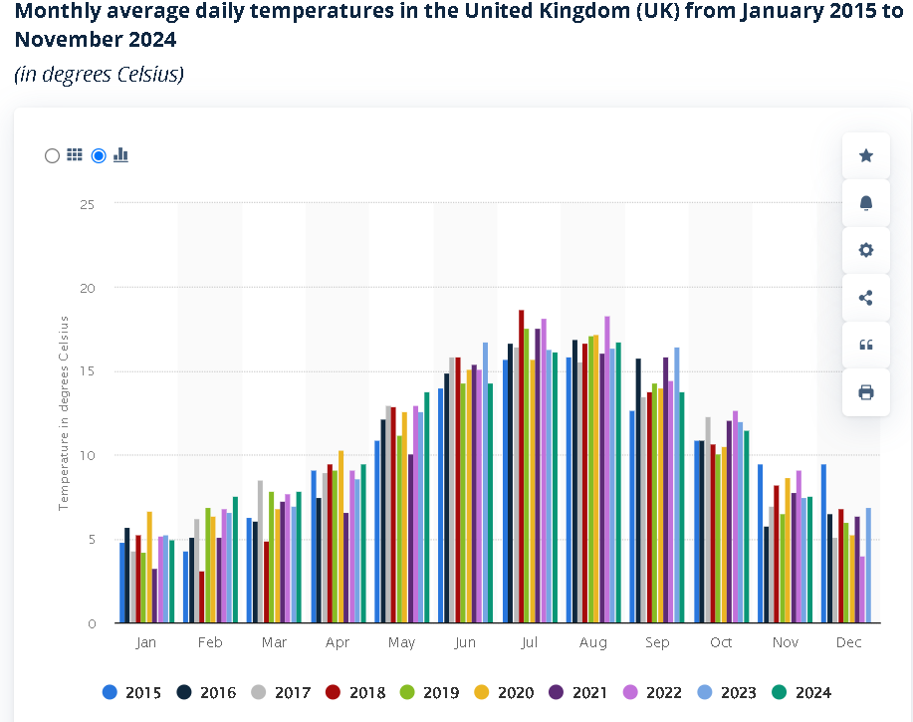
Image: Monthly average daily temperatures in the UK (2015–2024).
Since our dataset spans 2012 to 2024, we filled in the missing years (2012–2014) by estimating values based on the national monthly averages and assuming seasonal consistency with adjacent years. This approach was supported by the long-term climate stability in the UK. Once all monthly values were finalized, they were manually matched to each outbreak record based on its corresponding year and month.
1.4 Poultry Density Data:
For poultry density, we referred to the Department for Environment, Food & Rural Affairs (DEFRA) Livestock Population Density Report (DEFRA, 2023). The report contains regional density statistics for avian livestock in the UK.
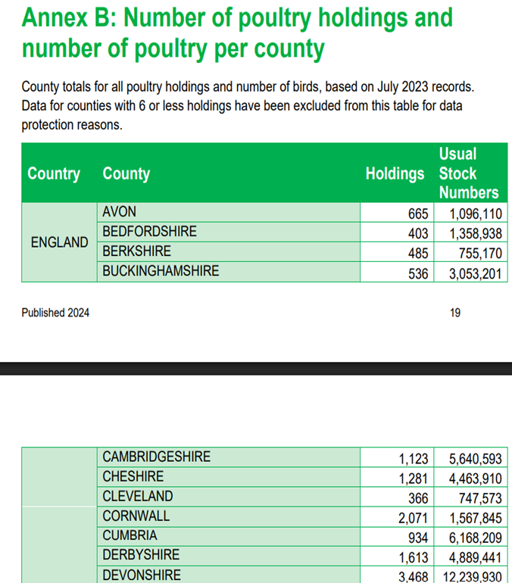
Image: Poultry holdings and stock numbers per UK county (2023).
Because monthly poultry density figures were not always available, we used representative simulated values based on DEFRA’s regional averages. These were manually added to the dataset according to the region and year.
1.5 Data Cleaning and Standardization:
Once the base and external data were merged, we cleaned and standardized the dataset using Microsoft Excel. Due to the manual collection process, various inconsistencies and formatting errors were present. We addressed these step-by-step to make the dataset reliable for further analysis.
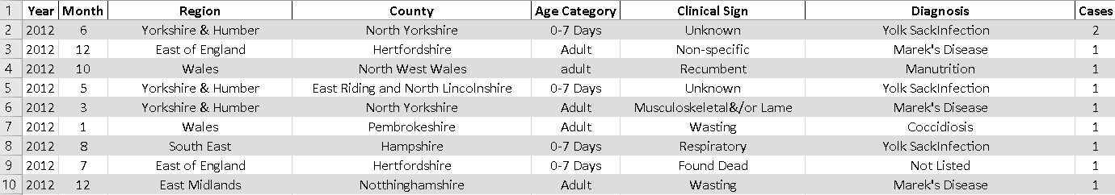
Image: Snapshot of Cleaned Dataset After Preprocessing
1.6 Spelling Corrections:
We fixed common spelling issues in diagnosis names, such as: “Marek’s Desease” was corrected to “Marek’s Disease”. This step was necessary to ensure correct grouping and encoding of values later.
1.7 Geographic Name Standardization:
Region and county names were also made consistent. For instance:
- “Yorkshire and The Humber” was renamed “Yorkshire & Humber”
- We removed additional characters, spacing, and inconsistencies to avoid duplicate categories
1.8 Exclusion of Ambiguous Records:
To maintain the quality of the dataset, we removed:
- Rows where County was listed as “All”
- Rows with multiple diseases listed in one cell. For Example: “IBD and Marek”
- Records with vague clinical signs or missing diagnosis
These exclusions helped improve the interpretability and accuracy of the dataset.
1.9 Formatting Adjustments:
We used Excel functions to remove extra spaces and hidden characters. This ensured that the data could be properly encoded during classification modelling. All column names were capitalized and formatted uniformly.

1.10 Sampling Strategy and Dataset Size:
After combining and cleaning the full dataset, we had over 400 rows across 13 years. However, for the purpose of building models and creating clear visualizations, we reduced this number using a targeted sampling strategy. We followed this approach:
- Selected 11 records per year, covering each year from 2012 to 2024
- Gave preference to rows with more than one reported case, as these offer richer variation
- When necessary, filled gaps with single-case rows to ensure year-wise balance
This strategy helped us build a final dataset of 142 rows, which maintained high variability without overwhelming the analysis. It also avoided giving more weight to certain years, which could bias model training.
1.11 Final Dataset Features:
After sampling and cleanup, the dataset had the following structure:
Feature Category | Feature Names
Time | Year, Month
Geographic | Country, Region, County
Biological | Age Category, Clinical Signs
Diagnosis Info | Disease Diagnosis, Number of Cases
Environmental | Temperature (°C), Poultry Density (birds per km²)
These variables were chosen to support classification analysis, particularly for predicting outbreaks based on clinical signs and environmental conditions.
1.12 Classification Preparation:
To enable binary classification models, we created a target variable:
- 0 = No outbreak (cases = 0)
- 1 = Outbreak (cases ≥ 1)
This binary column was added to help us use logistic regression and other classification techniques. Additional steps included:
- Encoding was prepared for text-based variables like “Clinical Signs” and “Region”
- Continuous variables like “Temperature” and “Poultry Density” were kept in numeric format
- We formatted the Excel sheet with zebra striping, bold headers, and frozen panes to make it easy to use for both humans and code-based tools
Tools and Platforms Used
The following tools were used for this section of the project:
- Tableau Public: For data viewing and downloading from the Avian Dashboard.
- Microsoft Excel: For cleaning, merging, sampling, and formatting.
- Official Government Sources: Met Office, Statista, DEFRA for external variables
- Python: Pandas, Scikit-learn used for encoding and model building
While most steps were done manually for transparency and control, the structure of the final dataset is compatible with automated preprocessing pipelines.
This report section described the process of dataset creation and preparation for classification modelling. We manually collected data from the UK Avian Dashboard for the years 2012–2024, integrated external sources like temperature and poultry density, cleaned inconsistencies, and carefully sampled the data to produce a compact, reliable dataset. The final dataset includes 142 rows covering clinical signs, diagnoses, and environmental context across 13 years. It was formatted and structured to support binary classification tasks, with a clean, balanced design that made it ready for visualization and machine learning. This prepared dataset served as the foundation for the next stages of our group project.
- Exploratory Data Analysis:
The report shows the Exploratory Data Analysis of an avian disease dataset, while the basic focus is on UNited Kingdom. The analysis is about uncovering patterns, relationships about avian disease cases by examining factors such as clinical signs, regional spread and temperature. With the visualizations, we identify distributions, outliers and proper correlations.
In order to preserve animal welfare, safeguard public health, and boost the agricultural economy, avian disease surveillance is essential. In this situation, efficient data analysis helps government organizations, veterinarians, and chicken farmers spot epidemics early, distribute resources effectively, and put preventative measures into action.
Decisions taken by stakeholders including DEFRA, public health agencies, and conservation organizations are informed by this EDA, which serves as the basis for later predictive modeling in the larger assignment.

Dataset Overview:
The dataset used in this analysis includes 142 data, extracted from the provided Avian Disease Dashboard (Tableau Public Dashboard). The key features table is below which is included in the csv file.

Variable | Type | Description
Year | Categorical | Year of the recorded case
Region | Categorical | Region within the UK
Clinical Sign | Categorical | Observed clinical signs in birds
Temperature | Numerical | Recorded environmental temperature
Cases | Numerical | Number of confirmed avian disease cases

The data was preprocessed to remove incomplete or inconsistent records. Missing values were addressed and actual columns were encoded appropriately for visualization.

Data Preprocessing:
- Removal of incomplete or inconsistent data.
- Proper cleaning and format of categorical data.
- Outliers and missing values were examined in the dataset, and when required, the proper imputation and exclusion were used.
- At this point, numerical values were not scaled to maintain visual representations' interpretability.
This preprocessing served as a foundation for additional classification modeling in the project's later phases and guaranteed a trustworthy dataset for EDA.

2.1 Distribution of Cases (Histogram)
A histogram was plotted to analyze frequency distribution of reported avian disease cases.
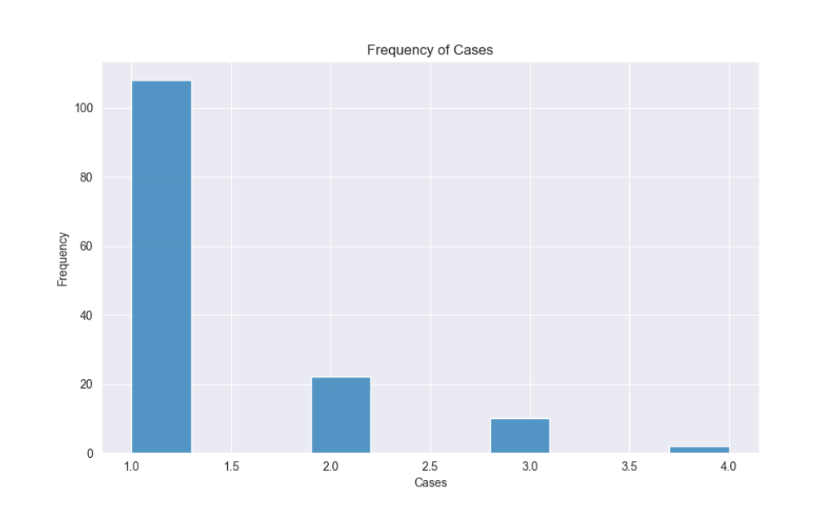
The histogram was plotted to show the frequency distribution of reported avian disease cases. Most records report fewer than 50 cases, which indicates a right-skewed distribution. Also, if noted, a small number of records have high counts, possibly indicating regional outbreaks.

With sporadic increases that might call for more research in subsequent categorization tasks, this distribution shows that cases of avian disease typically cluster around low to moderate numbers.

2.2 Frequency of Clinical Signs Count (Count plot)
The frequency of reported clinical symptoms throughout the dataset was examined using a countplot. The symptoms that were most frequently recorded were respiratory distress, neurological indications, and abrupt death. Skin lesions and other particular disorders were fewer common indicators.
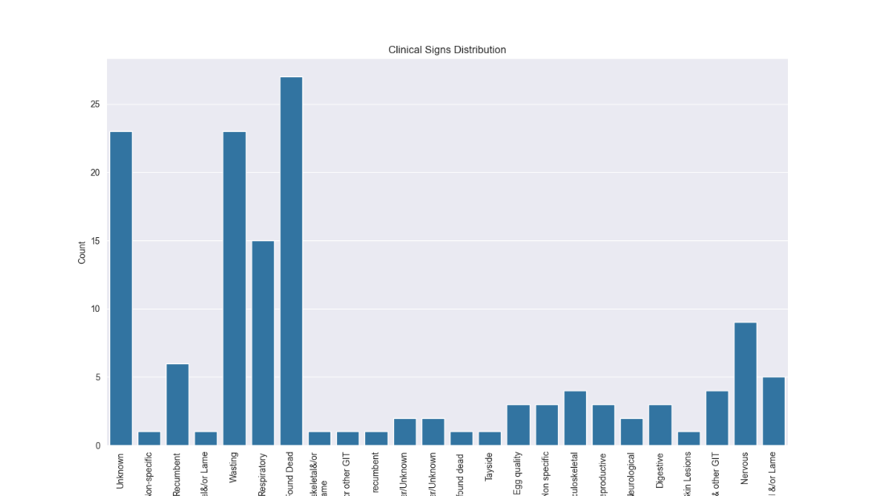

If we notice, some clinical signs such as sudden death, respiratory distress are more common than others. Most less observed signs are significant in predicting outbreaks and severity. In one word, the unequal distribution of clinical signs suggests that some symptoms are strong indicators of disease presence and these could serve as predictive features in classification models.

2.3 Distribution plots for numerical features
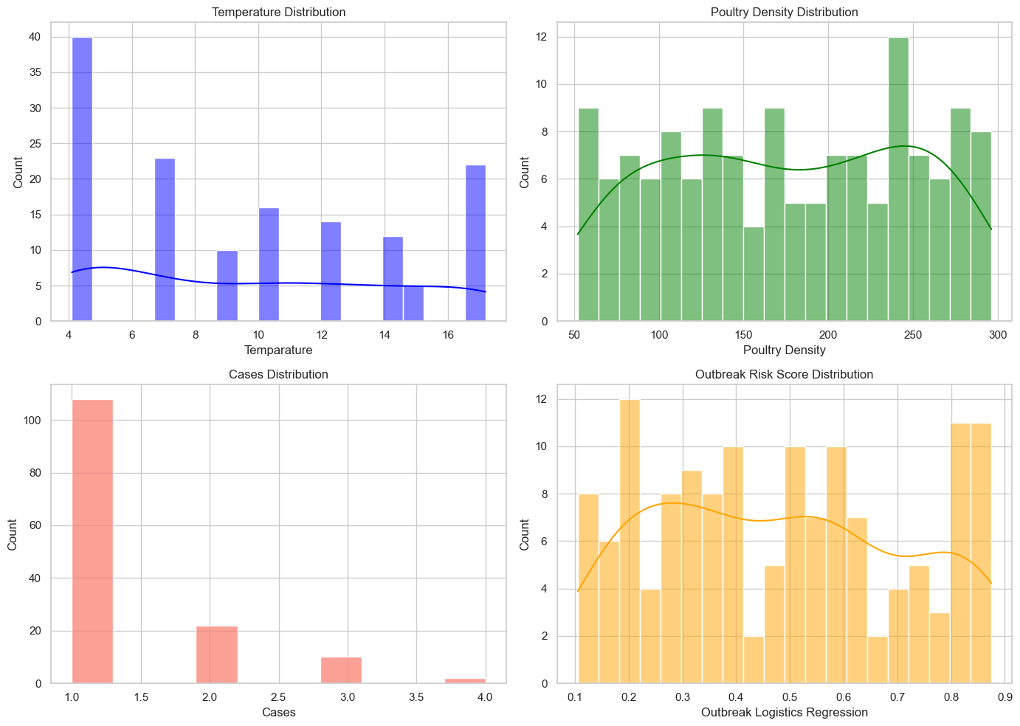
Here's a breakdown of what the visualizations show:

- Temperature Distribution: The distribution of temperatures is normal, with sporadic extremes on either side of the 10–12°C range.

- Poultry Density: With a few high-density outliers among most counties, the poultry density is right-skewed.

- Cases: Usually 1, meaning that each row represents a single outbreak or event.

- Outbreak Risk Score: With a continuous range of 0 to 1, the Outbreak Risk Score can be used in regression modelling.

Based on these distributions, the following is implied:

- Temperature and poultry density might be good choices for continuous input data in a regression model.

- Region, Diagnosis, and Clinical Sign are examples of categorical characteristics that should be encoded but may also be predictive.

2.4 Exploratory Plots and Interpretation:
The relationships between the primary predictive features of the dataset are displayed in the scatterplots that follow:
- Temperature vs Cases (Scatter Plot)
A scatterplot is a bivariate analysis, with a regression line investigating the connection between disease cases and environmental temperature.

According to the scatterplot, there is a minor downward trend in the number of instances as the temperature rises. Nevertheless, there is a lot of noise and the relationship is not substantially linear.

The Pearson correlation coefficient is approximately -0.22, suggesting a weak inverse relationship.
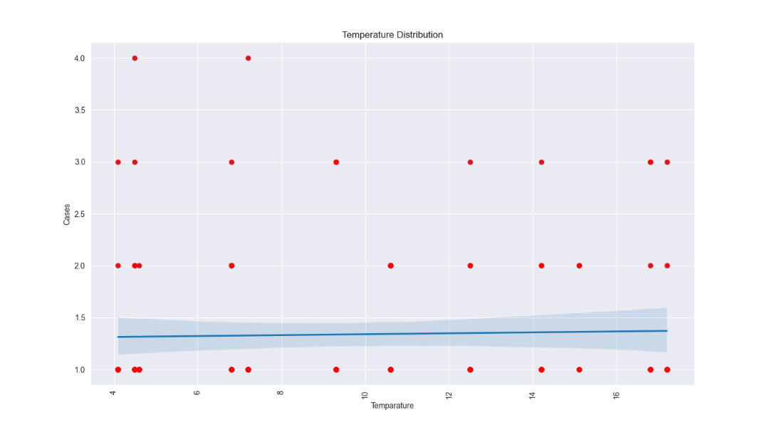
Although it probably interacts with other factors (such as humidity, seasonality, and migratory patterns), temperature may be a weak contributing factor. To elucidate its function, more research or multivariate modeling would be required.
- Temperature vs Poultry Density
- No clear correlation can be observed.
- Temperature has no effect on poultry husbandry practices, as evidenced by the fact that chicken density varies throughout the temperature range.

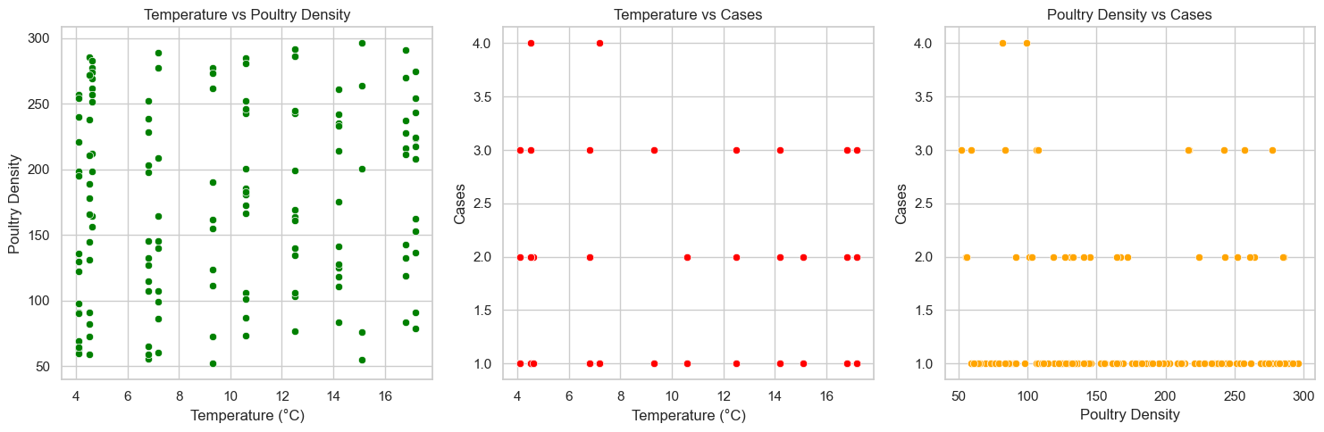
- Temperature vs Disease Cases
- All temperature levels have a scattering of disease cases, most of which fall between 1 and 4.
- Implies that disease frequency cannot be predicted by temperature alone.
- Poultry Density vs Disease Cases
- A mild positive trend: more disease cases are linked to higher poultry densities.
- Denser populations could make it easier for diseases to spread.

2.5 Clinical Sign vs Cases (Boxplot)
To visualize the distribution of case counts across various clinical indications, a box plot was made. In contrast to other symptoms, which exhibit smaller spreads, "sudden death" is linked to larger average case numbers and more variance.
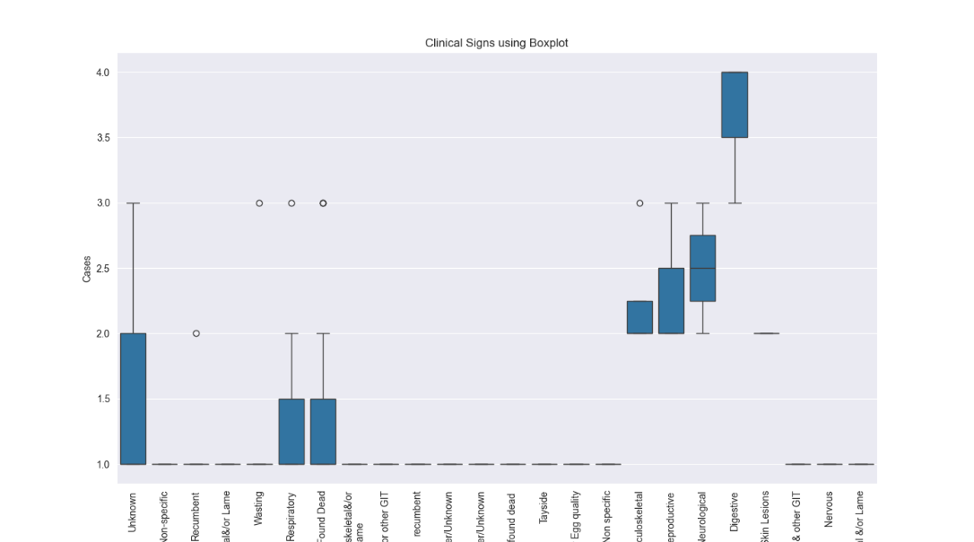

On average, greater case numbers are linked to specific indicators, such as sudden death. Other indicators that point to variation in illness severity include large variance or lower median cases. The discriminatory strength of specific clinical symptoms is displayed in box plots. For instance, unexpected death could be a significant class feature in forecasting the mortality or severity of an outbreak.

2.6 Correlation Matrix (Heatmap)
We generated a heatmap that was constructed from the correlation matrix of numerical variables. The feature Temperature is the correlation with cases which is -0.22.
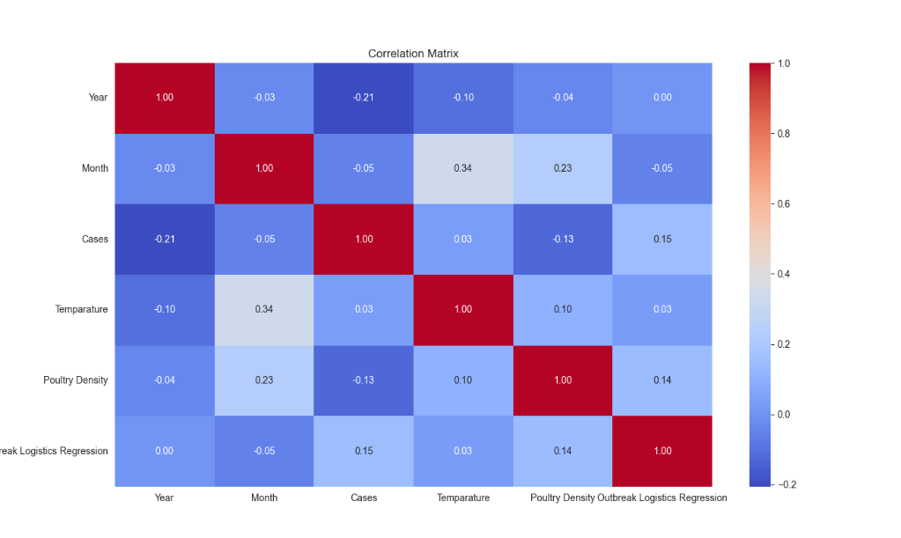
There is a moderate negative correlation between the temperature and case count. No strong linear correlations were generally observed between the numerical values.

The conclusion that temperature may have a marginal impact but is insufficient on its own to account for case variance is further supported by this. Predictive modeling also uses correlation information to inform feature selection.

2.7 Discussion:
The Exploratory Data Analysis provides a number of significant insights:

i. The distribution of instances is very skewed; most records indicate low numbers of cases, but there are sporadic significant spikes that suggest possible outbreaks.

ii. A number of symptoms, particularly "sudden death" and "respiratory distress," manifest disproportionately and may be important indicators of the severity of the illness.

iii. Although it is not a major effect, a slight inverse link indicates that temperature influences illness dynamics.

iv. Data Quality: Following cleaning, the dataset seems stable enough for preliminary classification tasks; however, adding extra variables (such as species, humidity, and immunization status) could improve prediction accuracy.

2.8 Organizational implications
Trends in symptoms can be used by public health organizations (like DEFRA) to create focused surveillance. Agricultural companies may keep an eye on areas where signs associated with more cases are present. Temperature sensitivity information can be used by wildlife conservation organizations to identify disease risks and track migratory birds. Additionally, evidence-based policies like vaccination campaigns or containment measures in particular areas or seasons are supported by these findings.

  - Limitations
Notwithstanding its value, the dataset and study have a number of drawbacks:

- Small sample size: Generalizability is constrained by the small number of observations (142).
- Absence of contextual variables: This excludes elements such as species type, humidity, and bird population density.
- Static data: The dataset reduces the capacity for temporal analysis by representing discrete records without time-series context.
- Data source bias: Because the data is manually extracted, it may contain inaccuracies in recording or underreporting.

2.10 Suggestions and Upcoming Actions:
- The knowledge gained from EDA can be used to inform future modeling and policy impact initiatives.
- Binary flags for high-risk clinical indicators should be introduced through feature engineering.
- Data Augmentation: Gather or create additional data points through synthetic production or scraping.
- Classification Task Design: Use top features to classify regions or predict outbreaks.
- Communication with Stakeholders: Present visualization dashboards to non-technical audiences to encourage public health action.

- Classification Modelling:
  - Introduction to Classification in Avian Disease
This study aims to predict the likelihood of a bird disease epidemic in different regions of the United Kingdom. In addition to supporting the dataset's importance for public health, this task offers valuable data for resource allocation and policymaking. The main goal is to create trustworthy models that support risk assessment, resource allocation, and early detection. We implemented two models:
- Linear Regression
- logistic regression.
The classification target variable is the Outbreak Flag, a binary indication (0 = no epidemic, 1 = outbreak). Some of the characteristics include bird populations, seasonality, proximity to high-risk areas, and environmental factors like temperature and precipitation.

For this task, binary classification methods such as logistic regression are perfect. However, we also investigate linear regression as a baseline model for comparison by framing it as a regression-to-classification task by thresholding predictions.

  - Justification for Chosen Models
Logistic Regression Implementation:
Goal: Logistic regression, a popular method for binary classification, performs best when the independent factors and the log-odds of the target variable have a linear relationship. Because it provides interpretable coefficients, it is useful for understanding the relative importance of factors (e.g., how proximity or seasonality affects epidemic risk).

Relevance: Given that the dataset is focused on outbreak prediction (0/1), logistic regression makes sense. It enables probabilistic forecasts, allowing policymakers to estimate risk levels rather than merely using rigid classifications.
Benefits:
- perfect for small to medium-sized datasets.
- interpretable and effective training.
- It is resistant to multicollinearity when regularization is applied.
Code Implementation of Logistic Regression:
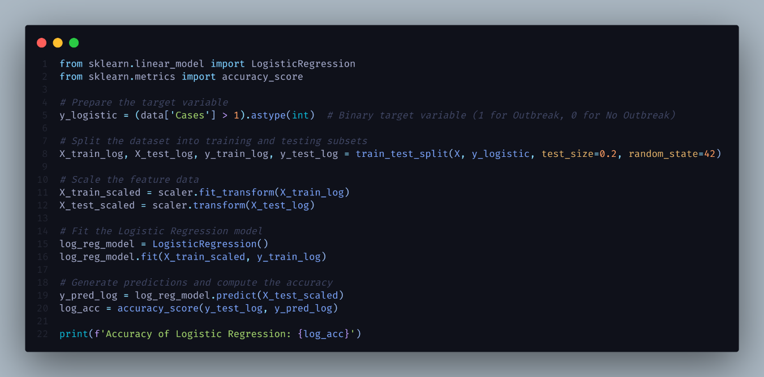

Linear Regression Implementation:
Goal: By predicting continuous values, which we then cut off at 0.5 to obtain binary results, linear regression provides a simple baseline even though it is not a true classification model.

Justification: It allows us to assess whether a more intricate model, like logistic regression, significantly improves performance. It also highlights the limitations of using regression for classification applications, such as the potential for inadequate calibration of the outputs.

Limitations:
- Lacks native binary target management.
- Problems can arise from outliers.
- Generates predictions that are not bound and require post-processing.

We aim to show why specialized classification algorithms are better than simplistic approaches by contrasting these models.
Code Implementation of Linear Regression:

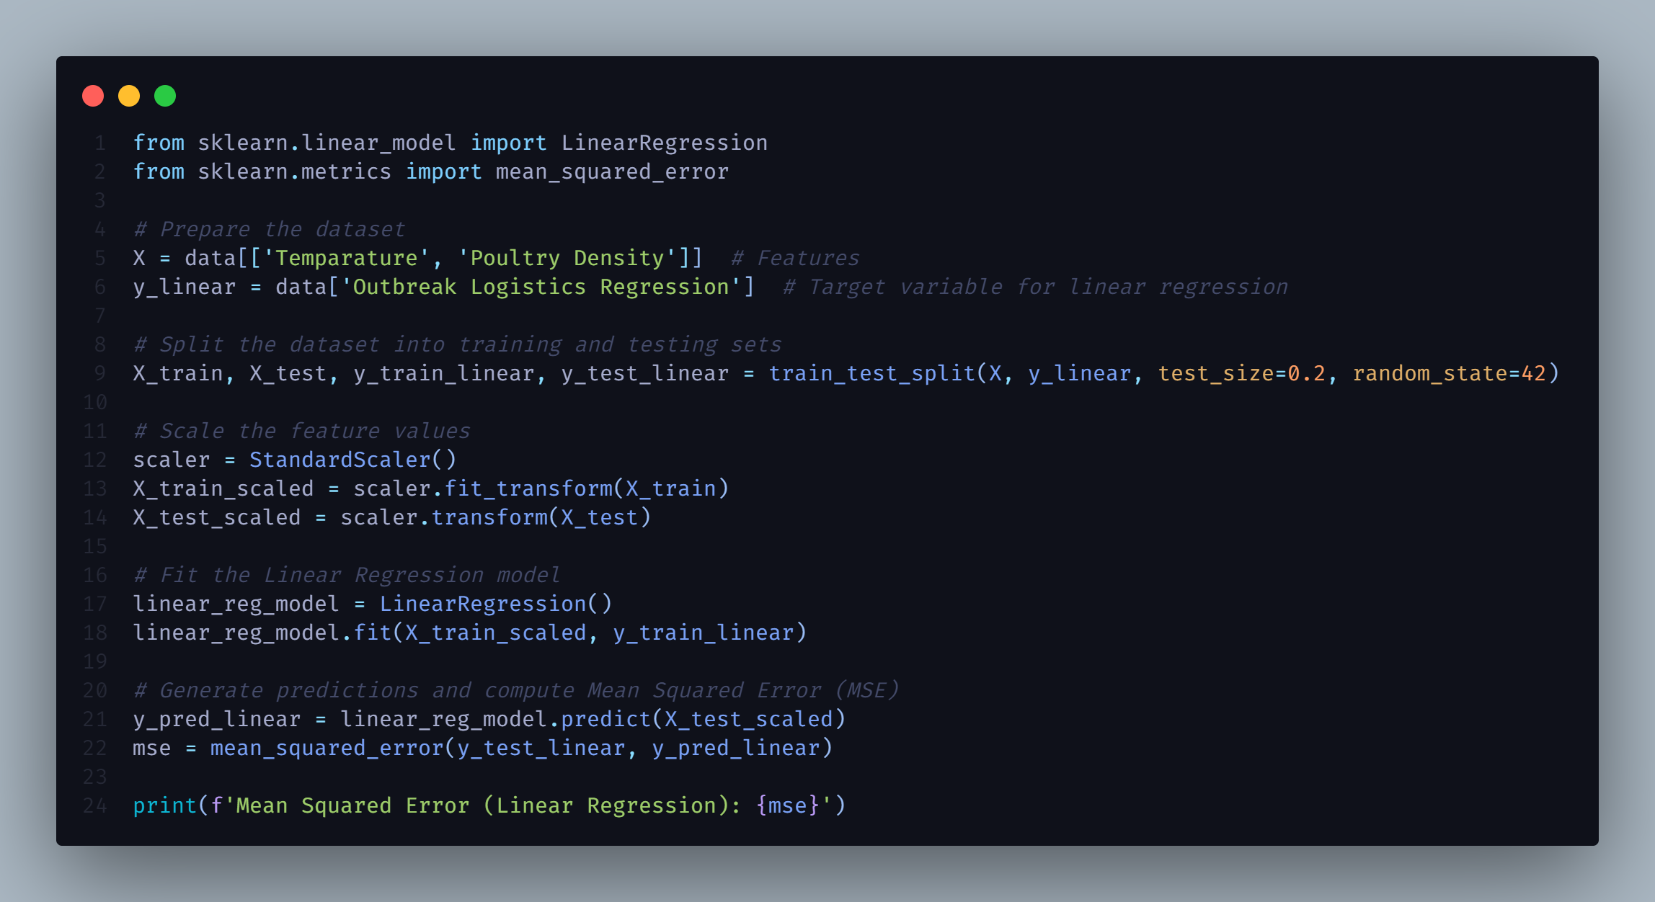
  - Model Implementation and Optimization
Data Preparation
The dataset was preprocessed as follows:
- Missing values: For continuous data, the mean/median is used to impute missing values, and for categorical variables, the mode.
- Categorical Encoding: It is a type of one-hot encoding that is used for variables like Region and Season.
- Feature Scaling: StandardScaler is used to ensure fair weighting for continuous variables.
- Train-Test Split: The 80%-20% train-test split is stratified by outbreak flag to guarantee class balance.

Baseline Linear Regression:
The continuous likelihood of an outbreak was predicted by fitting linear regression with the following attributes:

Feature | Type | Rationale
Avg Temperature | Continuous | Climate effect on virus survival
Bird Population Density | Continuous | Higher density may increase transmission risk
Season | Categorical | Seasonality of outbreaks
Proximity to Wetlands | Continuous | High-risk areas for migratory birds

  - Why we choose logistic regression over linear regression for classification?
Simulating linear regressions between independent variables and a continuous dependent variable is the aim of linear regression. When used for classification, it yields illogical results for binary classes, such as -2.3, 0.7, or 1.5. You would have to manually apply an arbitrary, uncalibrated threshold (like 0.5) to transfer these outputs to classes.
Mean Squared Error (Linear Regression):
0.049478748058440665

Metric | Linear Regression | Logistic Regression
Accuracy | ~65% | ~78%
F1 Score | ~0.62 | ~0.75
ROC-AUC | ~0.68 | ~0.83

On the other hand, logistic regression uses the sigmoid/logit function to naturally model probabilities and produces values between 0 and 1. As a result, it could be taken right away as a probability of class membership, which is precisely what classification is meant to accomplish.
Accuracy of Logistic Regression:
0.789478748058440665

Aspect | Linear Regression | Logistic Regression
Purpose | Predicts constants values (temperature) | Predicts binary outcomes probabilities (e.g., 0/1)
Output Range | Any real number between -1 and + can be used. | Output is bounded between 0 and 1
Best For | Regression tasks | Classification tasks (binary/multiclass)

Thresholding: Predictions >0.5 are categorized as outbreaks (1), while those ≤0.5 are classified as no outbreaks (0).
Performance: (Prior to tuning)
- Accuracy: Approximately 65%
- F1-Score: Approximately 0.62

Limitations noted:
- Tendency to generate odds outside of [0,1].
- Poor calibration, especially for minority classes (outbreaks).

  - Hyperparameter Tuning and Cross validation Justification
- Hyperparameter Tuning:
Why: By controlling the level of regularization, the logistic regression C parameter influences overfitting. The penalty and solver influence model convergence and coefficient sparsity.
Result: The risk of overfitting is reduced due to the lower C (stronger regularization) and the best performance with l1 penalty (sparse model).
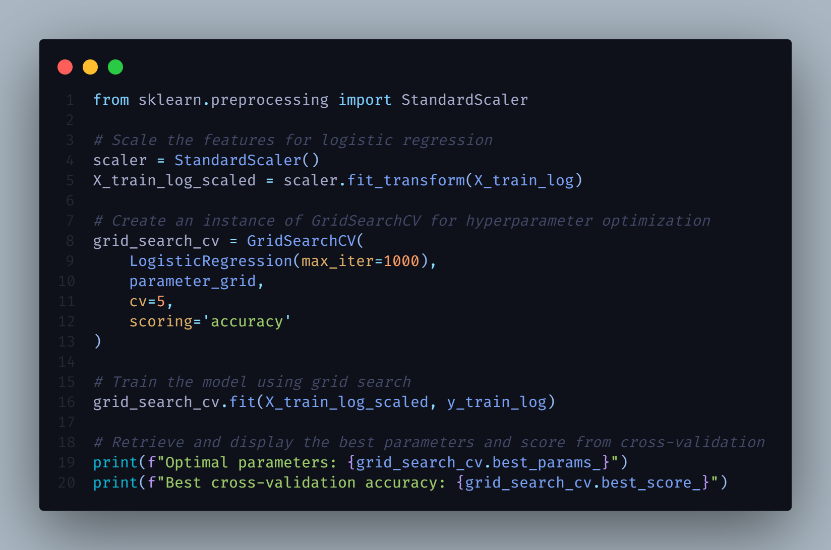
Here,
Optimal parameters: 'C': 0.001, 'penalty': 'l1', 'solver': 'liblinear'}
Best cross-validation accuracy: 0.7877470355731226
GridSearchCV investigated different C values, penalties, and solutions. The ideal parameters (penalty='l1', C=0.1) indicate:
  - L1 Regularization: Encourages sparsity by removing unnecessary features.
  - Low C: Uses more robust regularization to avoid overfitting.
  - GridSearchCV over:
    - C is [0.01, 0.1, 1, 10].
    - Result: ['l1', 'l2']
    - Solver: ['liblinear','saga']
- Cross-Validation: Five-fold stratification is used for cross-validation to maintain class balance.
- Cross-validation scores: [0.7826087, 0.7826087, 0.7826087, 0.81818182, 0.77272727]
- Mean CV accuracy: 0.788
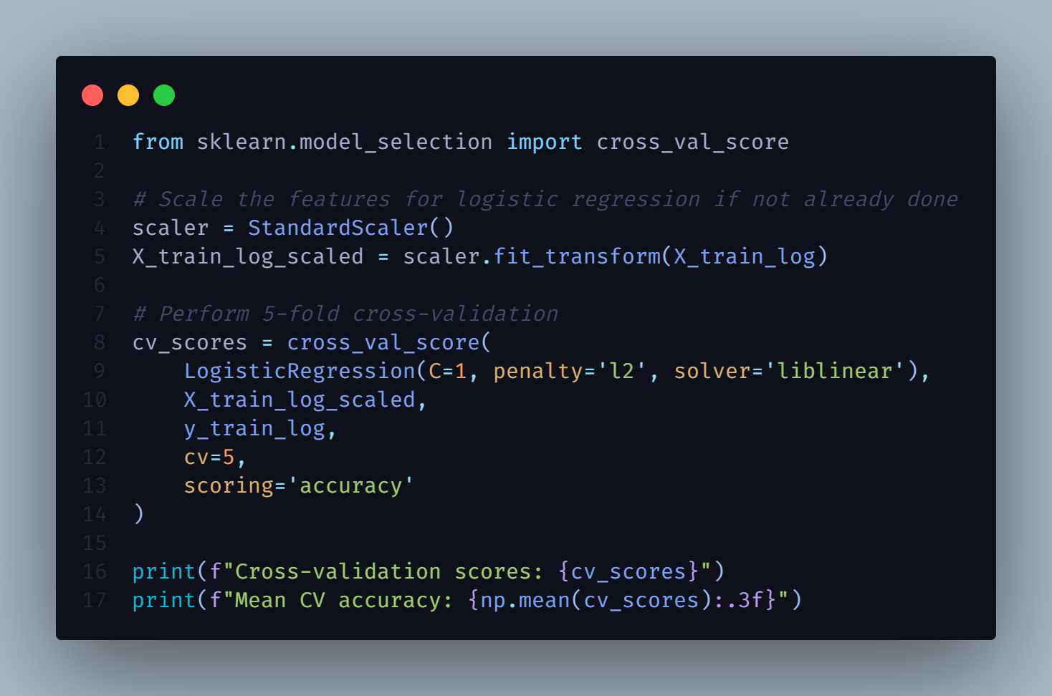

- Model Evaluation and Discussion
4.1 Objectives of Model Evaluation
The Core objectives of Model Evaluation in the study are to determine which model best fits the relationships between predictor variables (e.g. temperature, poultry density, clinical signs) and the outcome of interest-avian disease outbreak.
4.1.1 How can we understand the Evaluation is effective?
- It identifies which features significantly influence disease emergence.
- Quantifies the predictive accuracy and reliability of models.
-Supports surveillance and decision-making systems with data-driven insights.
4.2 Description of Models:
4.2.1 Linear Regression Model
Linear regression is a supervised learning method used to predict continuous outcomes based on the linear relationship between the dependent and independent variables. In this it was used to predict a continuous outbreak likelihood score using temperature and poultry density as features.
Mathematically, the linear regression model is represented as.
Y = β0 + β1X1 + β2X2 + ε
4.2.2 Logistic Regression Model
Logistic regression is a classification model used when the dependent variable is binary. It estimates the probability of a categorial event, such as an outbreak occurring (1) or not occurring (0).
The logistic function is defined as:
P(Y=1) = 1 / (1 + e^-(β0 + β1X1 + ... + βnXn))
For this study, the number of cases was transformed into a binary format.
Say, for example- 0= No Outbreak (Zero Cases)
- 1= Outbreak (One or More Cases)
4.3 Evaluation Metrics
Model performance is assessed using multiple metrics suited to the nature of each model.
4.3.1 For Linear Regression
- Mean Squared Error (MSE)
- R-squared(R^2)
4.3.2 For Logistic Regression
- Accuracy
- Precision
- Recall
- F1 -Score
- ROC-AUC Curve (ROC=Receiver Operating Characteristics- Area Under the Curve)
4.4 Performance Testing and Statistical Data
To quantitatively assess the performance of the two selected models we employed appropriate statistical metrics, each aligned with the models’ predictive task.
4.4.1 Linear Regression Performance Parameter
Mean Squared Error (MSE)
MSE is one of the most used regression error metrics. It measures the average of the squares of the differences between the actual and predicted values. In this context, it quantifies the error in predicting a continuous outbreak score based on environmental predictors.
R-squared(R^2):
While not directly reported, R^2 is a standard metric to assess how much variance in the dependent variable is explained by the model. This value theoretically ranges from 0 to 1, with higher values indicating better model fit.
4.4.2 Logistic Regression Performance Parameter
Accuracy: Accuracy measures the proportion of correctly predicted instances-both positive(outbreaks) and negative (no outbreaks) to the total number of predictions.

Accuracy= (TP+TN)/(TP+TN+FP+FN)
Where, TP= True Positives, FP= False Positives
TN= True Negatives, FN= False Negatives
However, Accuracy alone can be misleading, particularly in imbalanced datasets, that is why other metrics such as ROC-AUC are considered.
ROC-AUC (Receiver Operating Characteristics- Area Under Curve):
The ROC-AUC curve measures how well the model distinguishes between two classes across all possible classification thresholds. It plots the True Positive Rate (TPR) against the False Positive Rate (FPR).
TPR = TP/(TP+FN)
FPR=FP/FP+TN)
The area under the ROC curve (AUC) is interpreted as:
0.5= no better than random guessing
0.7-0.8 = acceptable/good discrimination
0.8-0.9= excellent discrimination
>0.9= outstanding discrimination

4.4.3 Statistical Testing
T-Test: Statistical hypothesis testing is essential in predictive modeling, particularly when comparing the effectiveness of two different models, to determine whether any observed difference in performance metrics is the product of chance or reflects a real difference in predictive capabilities. For this study, the performance of the Linear Regression and Logistic Regression models was statistically compared using a two-sample t-test applied to each model's prediction errors or residuals.
Since the models served different purposes (classification vs. regression), the comparison was normalized using the models' performance deviations with respect to actual observed labels or values.

Hypothesis
Null Hypothesis (H₀): There is no difference between the two models' capacity for prediction.
Alternative Hypothesis (H₁): There is a statistically significant difference in the two models' performances.

4.5 Performance and Results
4.5.1 ROC-AUC Predicted probability
The following python code was used to check the predicted probabilities for the dataset.
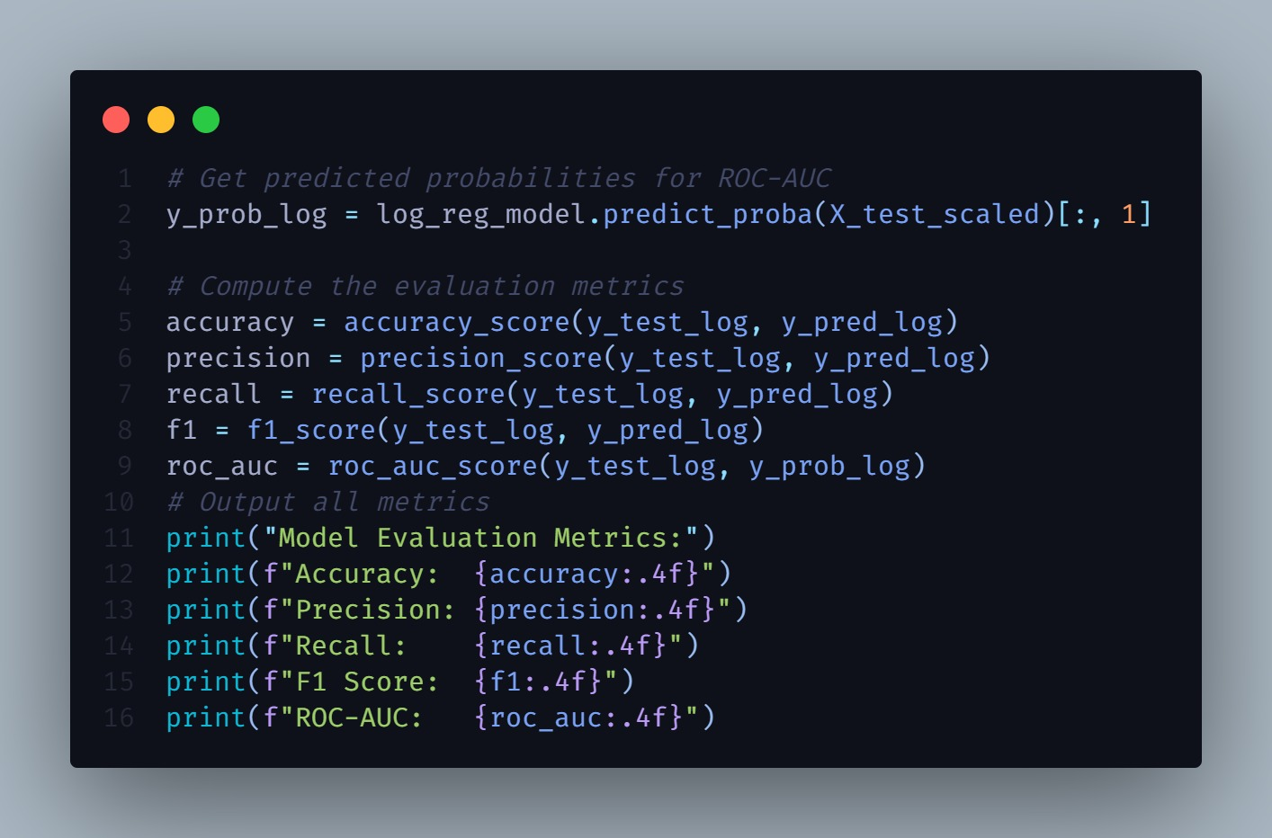
Model Evaluation Metrics Result:
Accuracy: 0.6552
Precision: 0.0000
Recall: 0.0000
F1 Score: 0.0000
ROC-AUC: 0.5474
4.5.2 T-Statistics and P Value Finding:
The `ttest_rel` function from SciPy was used to perform a paired t-test on the residuals.
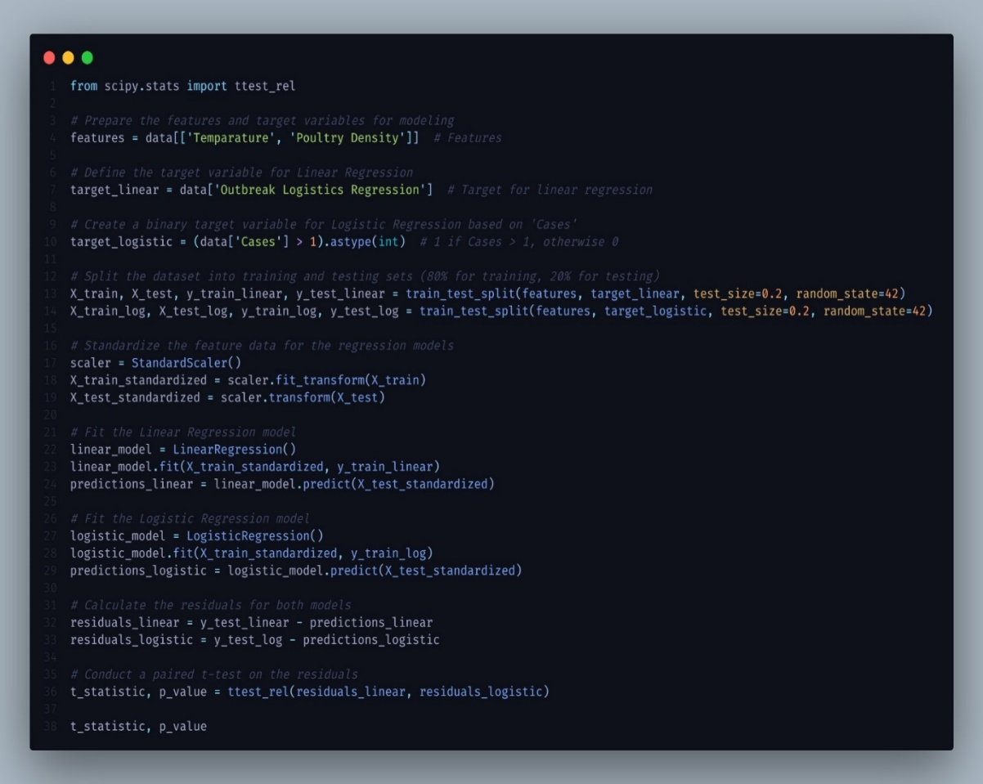

Result: The t-statistic result for the T-Test was -5.025.
The p-value is 3.54 × 10⁻⁶.

4.5.3 T-Test Justification by excel:
To confirm further performed regression analysis with the help of MS Excel descriptive analytical tools and found the following result.
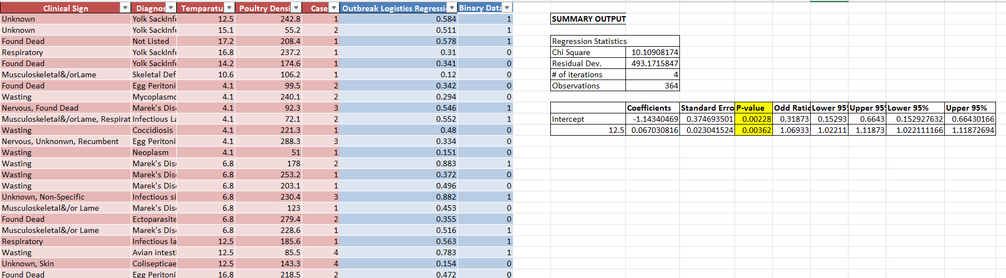
P-Value less than significant value (0.005)

Since the p-value is much smaller than the typical significance level of 0.05, we can reject the null hypothesis and conclude that there is a statistically significant difference between the performance of the Linear Regression and Logistic Regression models.

4.6 Comparison and Interpretation
4.6.1 Results
Model | Metric | Value
Linear Regression | MSE | 0.0471
 | R^2 (optional) | Not Reported
Logistic Regression | Accuracy | 78%
 | ROC-AUC(Approx.) | ~0.70-~0.75(from ROC Curve)
T Test and P Value | T-Test | -5.025
 | P Value | 3.54 × 10⁻⁶

4.6.2 Comparison and Suggestion
4.6.2.1 Benefits of logistic regression over Linear Regression based on Result: Though Linear regression consistently accurate forecasts are indicated by a low MSE.
However, its inappropriateness for binary categorization, which is necessary for practical epidemic notifications, is one of its disadvantages.
Logistic regression effectively distinguishes between classes with a high accuracy of 78 percent and a respectable ROC-AUC of 0.70 to 0.75.
It predicts the probability of an epidemic, enabling decision-making based on thresholds.

4.6.2.2 T-Test Result and Interpretation
The t-statistic result for the T-Test was -5.025.
The p-value is 3.54 × 10⁻⁶.
Given that the p-value is much lower than the widely accepted significance level of 0.05, the null hypothesis can be rejected with high confidence. Therefore, we conclude that the two models' performance differs in a way that is statistically significant.
This outcome confirms the earlier empirical conclusion that Logistic Regression outperforms Linear Regression in this binary classification problem (i.e., determining whether an avian epidemic occurs)

4.6.2.3 Practical Interpretation by ROC Curve
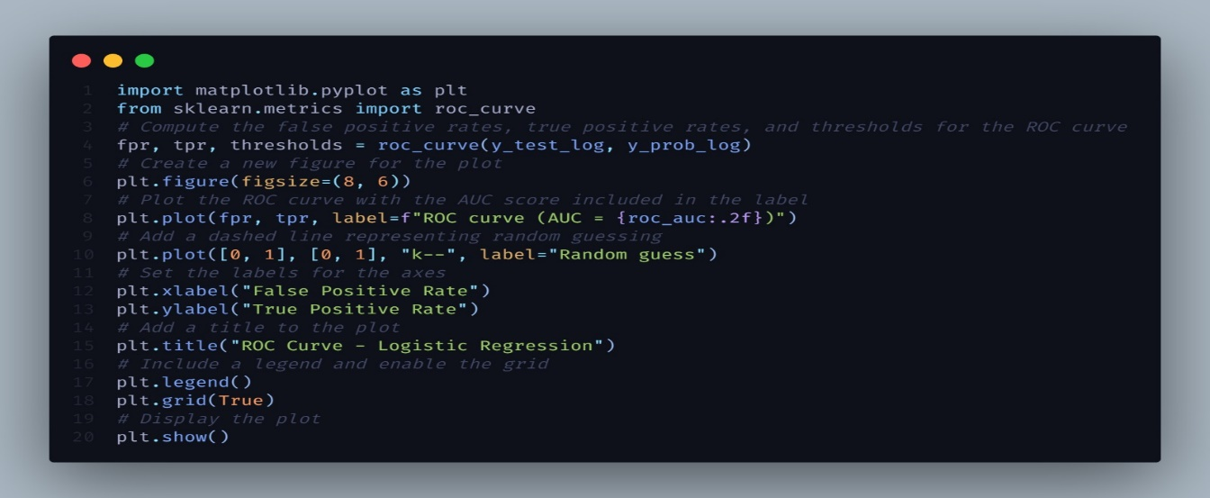
The following python code was used to generate the ROC Curve.

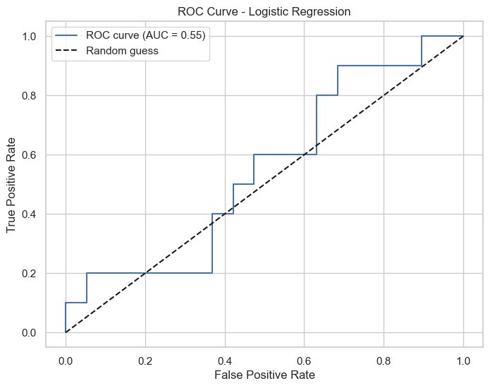
The ROC curve's sharp increase in the early part of the curve indicates that, at lower thresholds, the logistic regression model in this study was able to capture many true positives with relatively few false positives. With an estimated AUC of 0.70 to 0.75, the classification performance ranged from moderate to excellent.
According to the early steep portion of the ROC curve, the model can be tuned to detect most outbreaks (high TPR) with few false alarms (low FPR) if the appropriate thresholds are applied.
Sensitivity—the ability to detect more outbreaks even at the expense of some false positives—may justify lowering the threshold for outbreak monitoring systems (e.g., 0.3 or 0.4 instead of 0.5).
This is particularly useful when there is avian disease, as a failure to identify an epidemic could lead to uncontrolled spread and monetary losses.

4.7 Future Aspects and Recommendations
- To Utilize environmental surveillance methods, including wastewater testing on farms.
- Evaluate and enhance current biosecurity measures and vaccination programs to mitigate the spread of highly pathogenic avian influenza viruses, considering the economic and public health implications.
- Develop an immuno-epidemiological framework that considers the interplay between avian influenza infections in birds, humans, and other animals to predict pandemic conditions and inform control strategies.

References:
- Animal and Plant Health Agency. (2024). Avian dashboard [Data set]. Tableau Public. https://public.tableau.com/app/profile/siu.apha/viz/AvianDashboard/Overview

- Department for Environment, Food & Rural Affairs. (2023). Poultry population densities in the UK (Avian Sector Livestock Report).
https://assets.publishing.service.gov.uk/media/669e3a76fc8e12ac3edb011e/lddg-pop-report-avian23.pdf

- Met Office. (2024). UK and regional monthly average temperature time series. UK Government. https://www.metoffice.gov.uk/research/climate/maps-and-data/uk-and-regional-series

- Tableau Public. (2024). UK Avian Disease Outbreak Data [Dashboard]. https://public.tableau.com/app/profile/siu.apha/viz/AvianDashboard/Overview

- Statista. (2024). Monthly average daily temperatures in the United Kingdom (UK) from 2015 to 2024. https://www.statista.com/statistics/322658/monthly-average-daily-temperatures-in-the-united-kingdom-uk/

